A000-Mex-Mayan-Figurine-Calakmul-Snake king of the Kaanul dynasty-250-900 CE

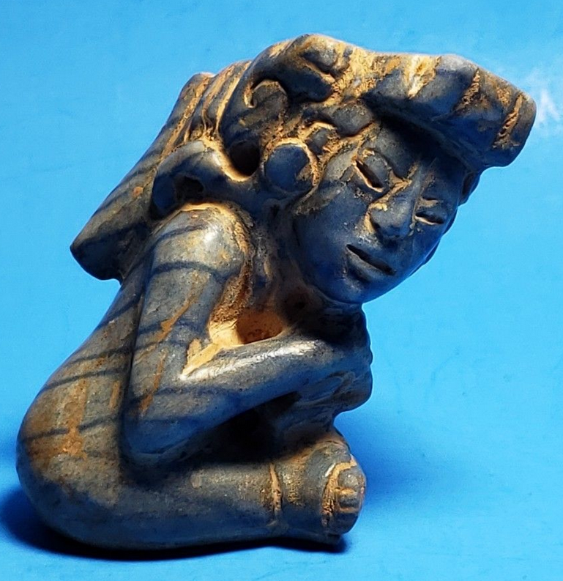 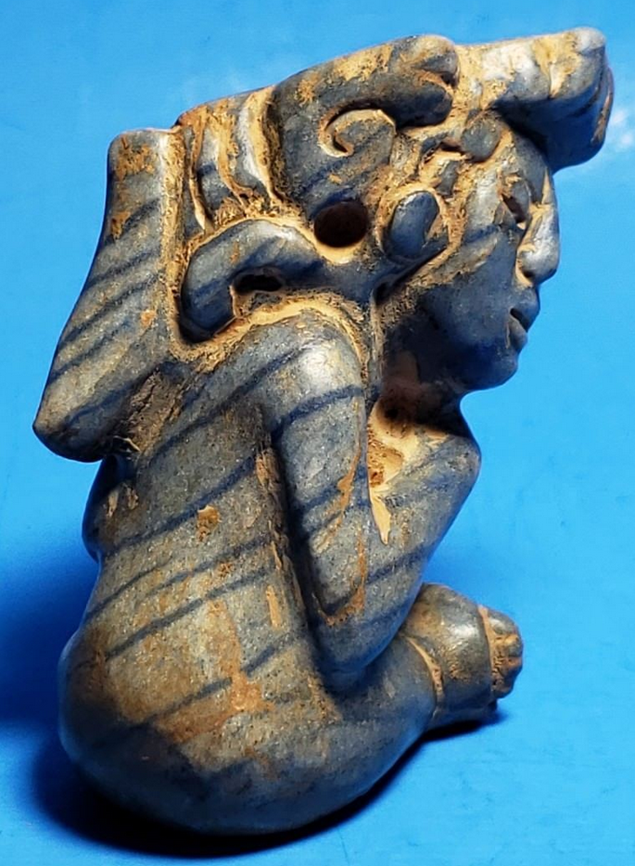 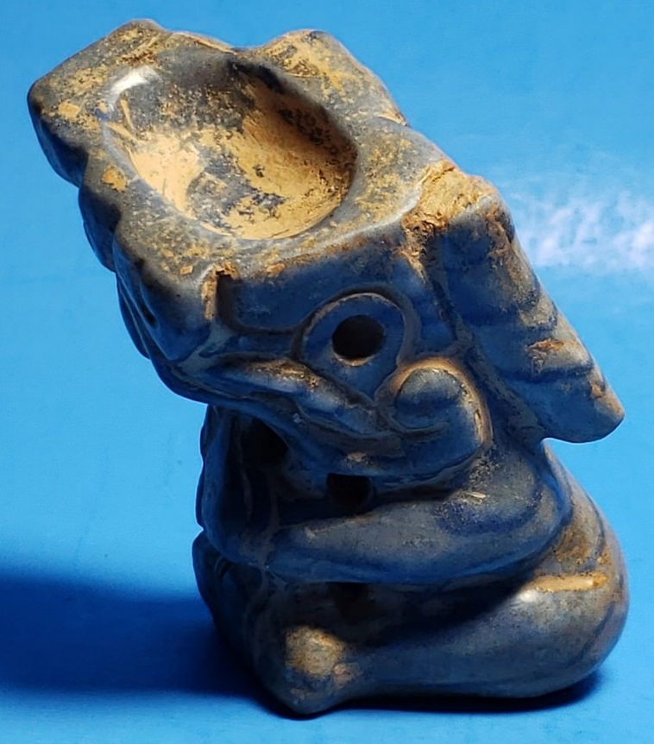



**Case no.:**

**Accession Number:**

**Formal Label:**

**Display Description:**

**This figurine depicts a** Snake king of the Kaanul dynasty-250-900 CE of Calakmul, with the serpent crawling up to his right ear. Calakmul was a major Maya power within the northern [Petén Basin](https://en.wikipedia.org/wiki/Pet%C3%A9n_Basin) region of the [Yucatán Peninsula](https://en.wikipedia.org/wiki/Yucat%C3%A1n_Peninsula) of southern Mexico. Calakmul administered a large domain marked by the extensive distribution of their emblem glyph of the snake head sign, to be read "Kaan". Calakmul was the seat of what has been dubbed the Kingdom of the Snake[[1]](https://en.wikipedia.org/wiki/Calakmul#cite_note-1) or Snake Kingdom. This Snake Kingdom reigned during most of the [Classic period](https://en.wikipedia.org/wiki/Mesoamerican_chronology). Calakmul itself is estimated to have had a population of 50,000 people and had governance, at times, over places as far away as 150 kilometers. There are 6,750 ancient structures identified at Calakmul; the largest of which is the great pyramid at the site. Structure 2 is over 45 metres (148 ft) high, making it one of the tallest of the Maya [pyramids](https://en.wikipedia.org/wiki/Mesoamerican_pyramids). Four tombs have been located within the pyramid. Like many temples or pyramids within [Mesoamerica](https://en.wikipedia.org/wiki/Mesoamerica) the pyramid at Calakmul increased in size by building upon the existing temple to reach its current size. The size of the central monumental [architecture](https://en.wikipedia.org/wiki/Maya_architecture) is approximately 2 square kilometres (0.77 sq mi) and the whole of the site, mostly covered with dense residential structures, is about 20 square kilometres (7.7 sq mi).

Throughout the [Classic Period](https://en.wikipedia.org/wiki/Category:Mayan_Classic_Period), Calakmul maintained an intense rivalry with the major city of [Tikal](https://en.wikipedia.org/wiki/Tikal) to the south, and the political maneuverings of these two cities have been likened to a struggle between two Maya superpowers.

**LC Classification:**

**Date or Time Horizon:**

**Geographical Area:**

**Map:**

**GPS coordinates:**

**Cultural Affiliation:** Mayan

**Media:**

**Dimensions:** 2 1/2" tall, 1 1/2 " wide 1 1/2" deep

**Weight:**

**Condition:**

**Provenance:**

**Discussion:**

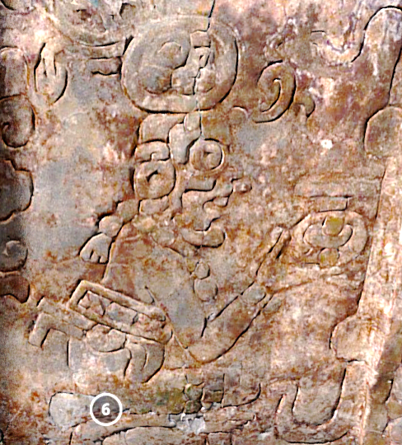

The Holmul Frieze (Building A, Group II)

<https://sketchfab.com/models/4432a0388b2346eeb00f43dc5d9c955d>

A 26-foot-long frieze in the city-state of Holmul depicts a complex religious scene with an inscription that suggests close ties with the Snake dynasty. The central figure is the Holmul king who died around 590 and was buried in the tomb the frieze adorns.

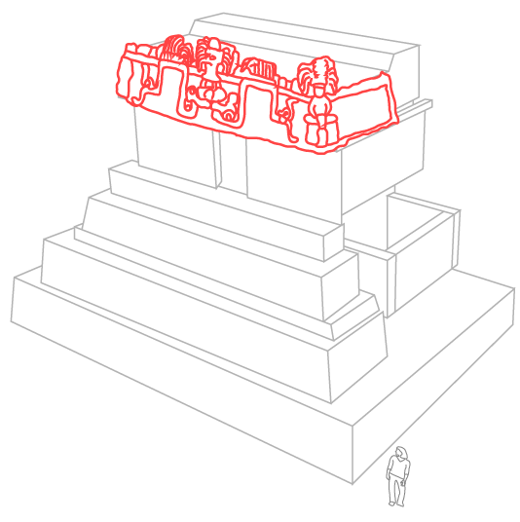

**https://www.nationalgeographic.com/interactive-assets/hidden-empire/v12/assets/img/holmul_pyramid_sm.png**

**References:**